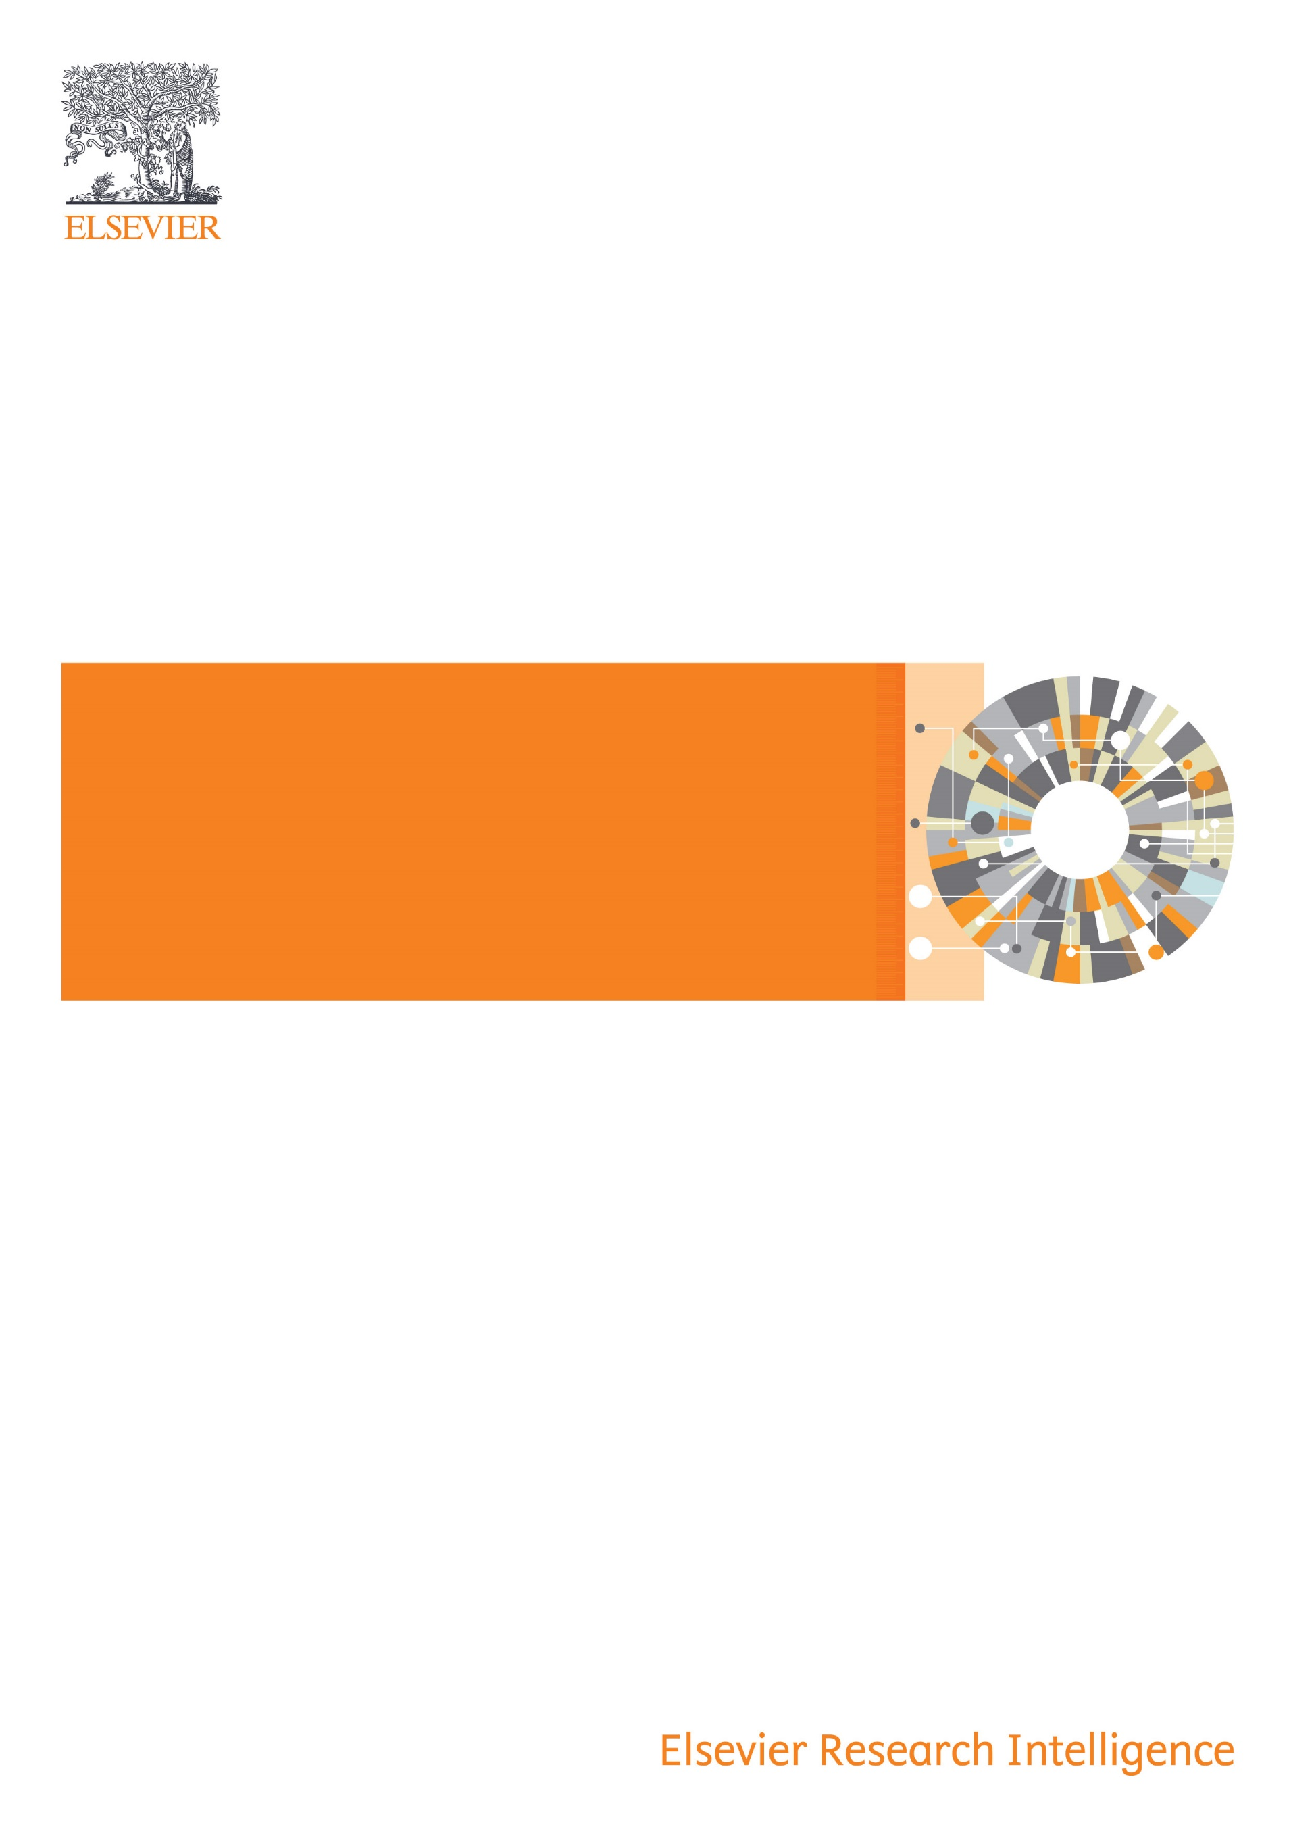
Digital Commons
Journal Management and Publishing Platform
Association of arab universities

Digital Commons Publishing Proposal

Project Mission

Publishing in academic journals continues to be the gold standard for academic excellence and achievement, and the cornerstone of global university rankings. At the same time, not all academic journals have the same visibility on the global arena: perhaps because they are in a non-English language, or in lesser served fields such as humanities and social science; or perhaps because the tools of professional journal publishing have been out of reach financially or organizationally. As a result, in many parts of the world, universities and countries are under-valued and under-recognized for the valuable research published in their locally managed journals.
We share with the AAU a mission:
- to make the academic journals published in the Arab world more discoverable, visible, and impactful in the global arena
- to make sure that every member country has sustainable access to a professional, stable, and scalable publishing platform for its academic journals
- to demonstrate success and grow the AAU’s journals program as the best place for journals in the region to reach their full potential and accurately represent the value of Arab world research

Proposed Solution and Benefits

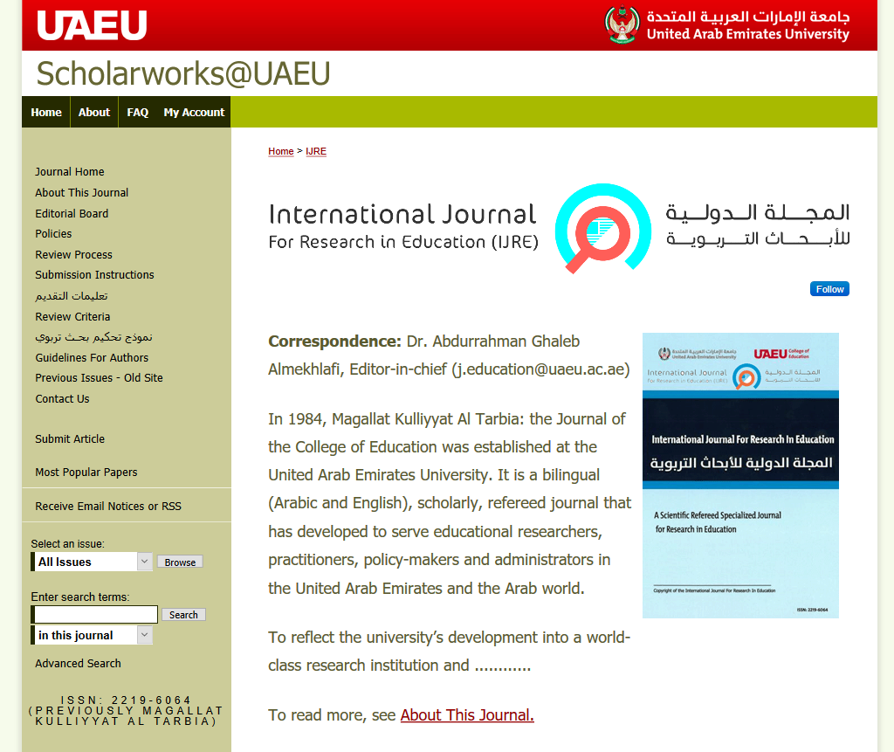
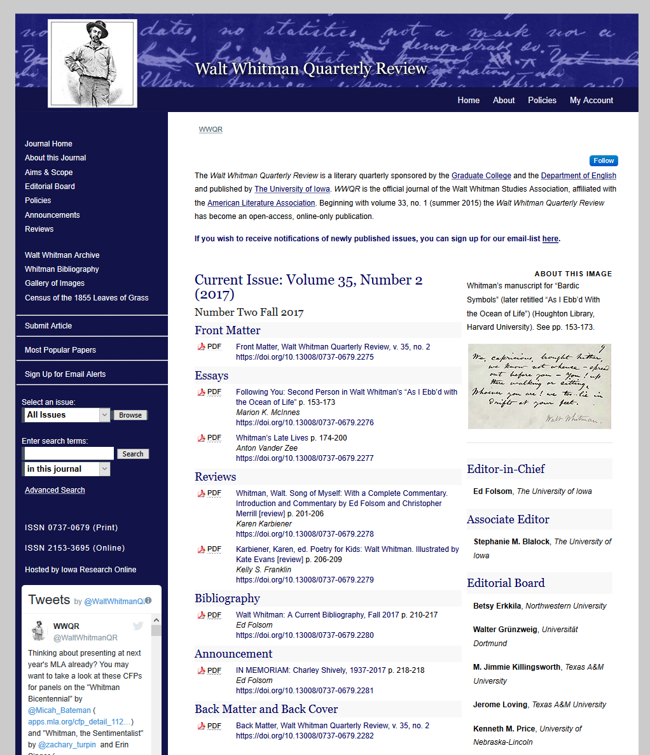
To achieve our shared mission in this project, we propose Digital Commons as a comprehensive publishing platform. Used by nearly 2,000 journals in the U.S. and around the world, Elsevier’s Digital Commons is a state of the art publishing service that has helped hundreds of institutions, societies, and journals improve their global visibility and impact. It combines submission management and peer-review software with an engaging journal publishing interface optimized for readership and discoverability on the open web, with metrics to demonstrate impact around the world. Journals using Digital Commons benefit from dramatically reduced workloads and turnaround time from article submission to publication; full hosting, support, and custom design; and far greater discoverability and readership.

Over half the journals hosted on Digital Commons are in the social sciences (especially law, economics, education) and the humanities, and our solution is well-matched to meet the unique challenges these journals face: support for local language, support for media-rich content, and support for alternative metrics which demonstrate societal impact and reach outside of traditional academia.

Each journal receives:
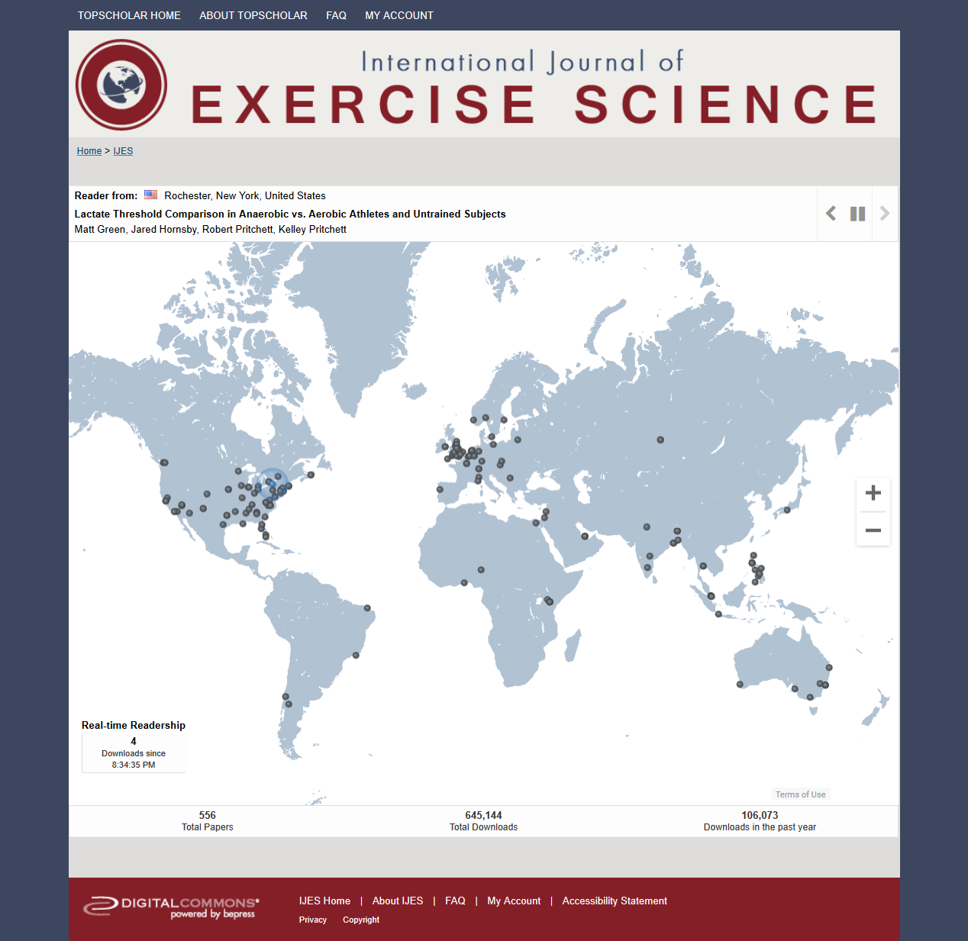
- easy to use editorial management and peer-review tools, with customizable workflows
- online front-end journal publishing, compliant with web standards and mobile viewing
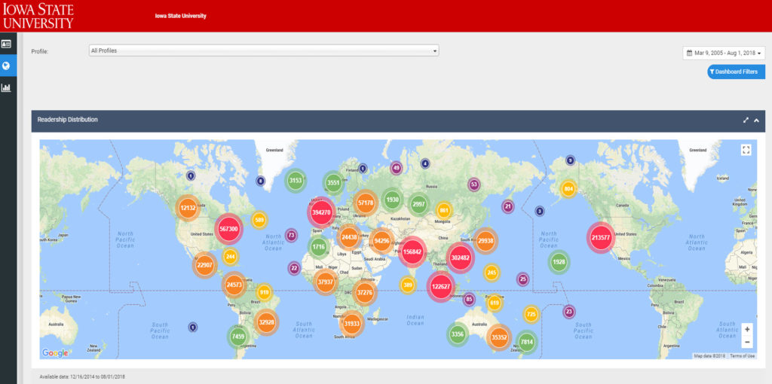
- media-rich publishing including social media, download maps, video, and multi-lingual display
- highly optimized for open web discovery (Google) and inclusion in academic search engines (Google Scholar)
- additional professional publishing and editorial services (such as ISSN registration) are also available
In addition, built-in features on Digital Commons make sure that every journal is in a strong position for Scopus review:
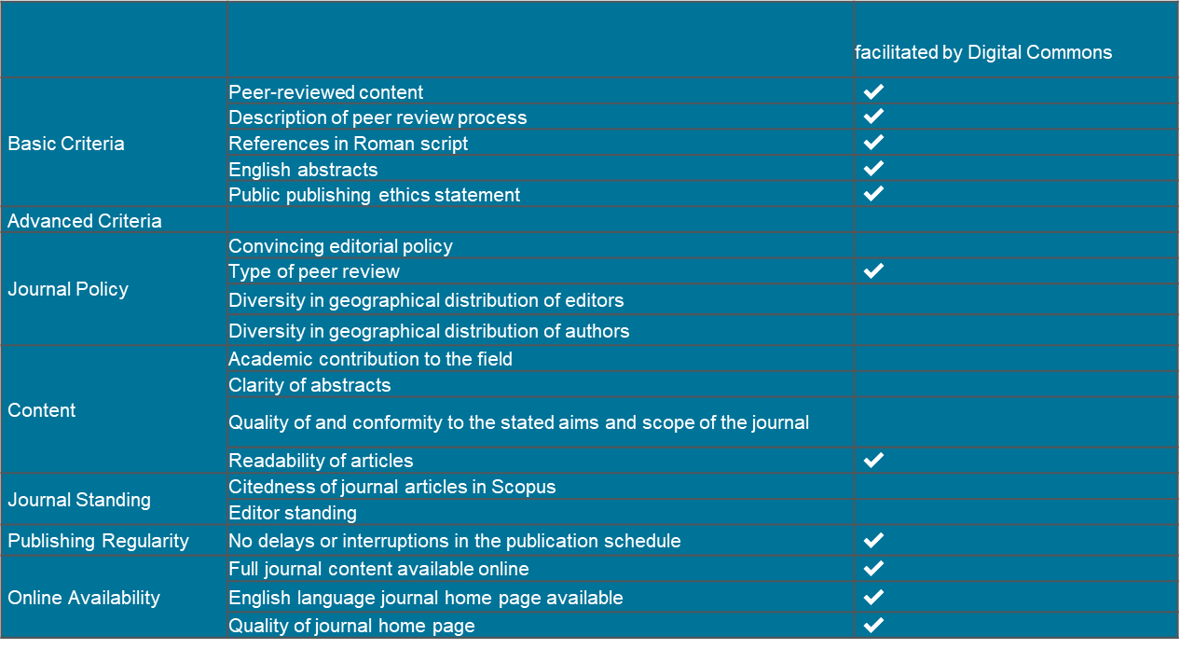
Simply by being hosted on Digital Commons, a journal meets all the basic criteria and many of the advanced criteria. Furthermore, Digital Commons provides tools to help editors make progress on the rest of the criteria:
- more submissions from more geographically diverse authors, higher quality publications, and more citable papers, thanks to far greater global visibility
- easier recruitment of editors and editorial board members, thanks to global visibility and a professional brand and web page
- a stable web platform and easy editorial management tools frees up editors’ time to focus on what matters most: improving the journal’s editorial quality

Implementation and Support

Digital Commons is a fully hosted Software as a Service. All software maintenance, configuration, and implementation is handled by the Digital Commons systems and development team. There is no software work or installation needed by the customer.

Digital Commons features a deep and comprehensive support model, which has enabled hundreds of universities and associations to launch and maintain successful journal publishing programs. The Digital Commons license includes English-language support and training on demand throughout our agreement, at no additional cost. Live web and phone training is provided to the Association’s team, via a central point of contact at the Association, whenever and as many times as you need (time zones permitting).

For each journal, as it launches, we will work with the Association’s central point of contact to provide:
- a single standardized design in agreement with the Association, with the option for distinct logos for each journal
- ISSNs registered for each journal as soon as the journal qualifies for an ISSN
- Typically, a journal design and launch process can take between 1-3 months

Please note that the Association’s team is responsible for preparing and uploading content using the tools built into Digital Commons. This will include: back issues for the journal; and names and email addresses of editors, reviewers, and editorial board members. Content can be submitted item-by-item, using our intuitive submission form which your Consultant can customize. Content can also be submitted in bulk ingests, using our Batch Upload and Batch Revise tool. Your support consultants will be available for unlimited trainings, help, and best practices to guide you to use these ingest tools.

